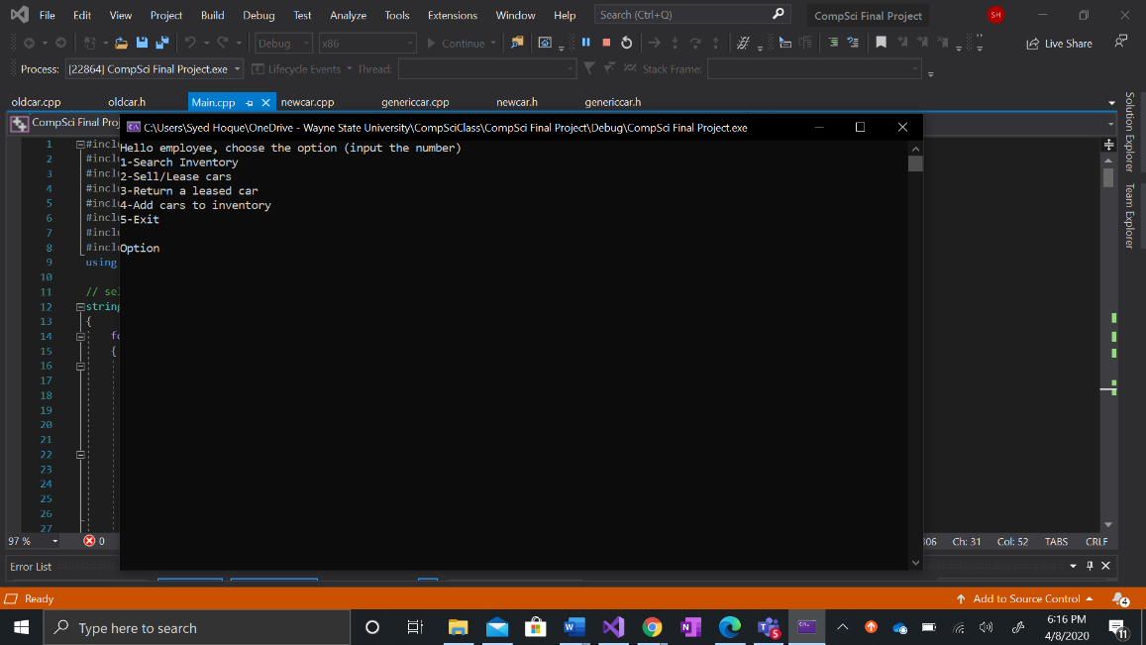 Main menu with options

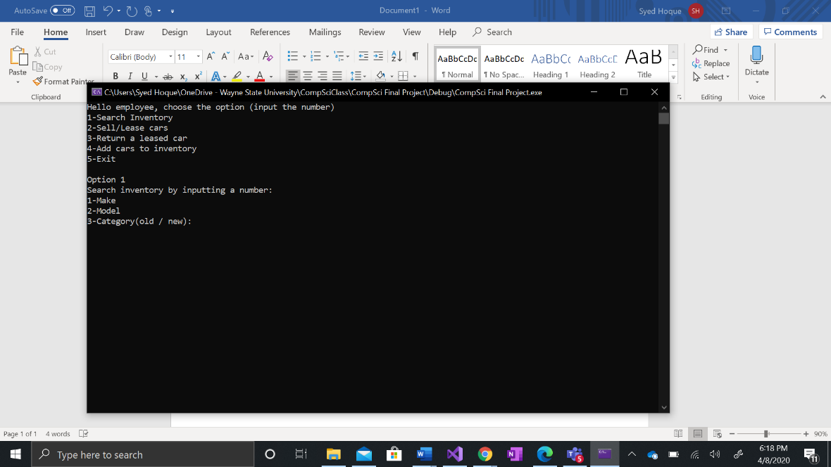 Search inventory option selected, with options to search by make, model and category

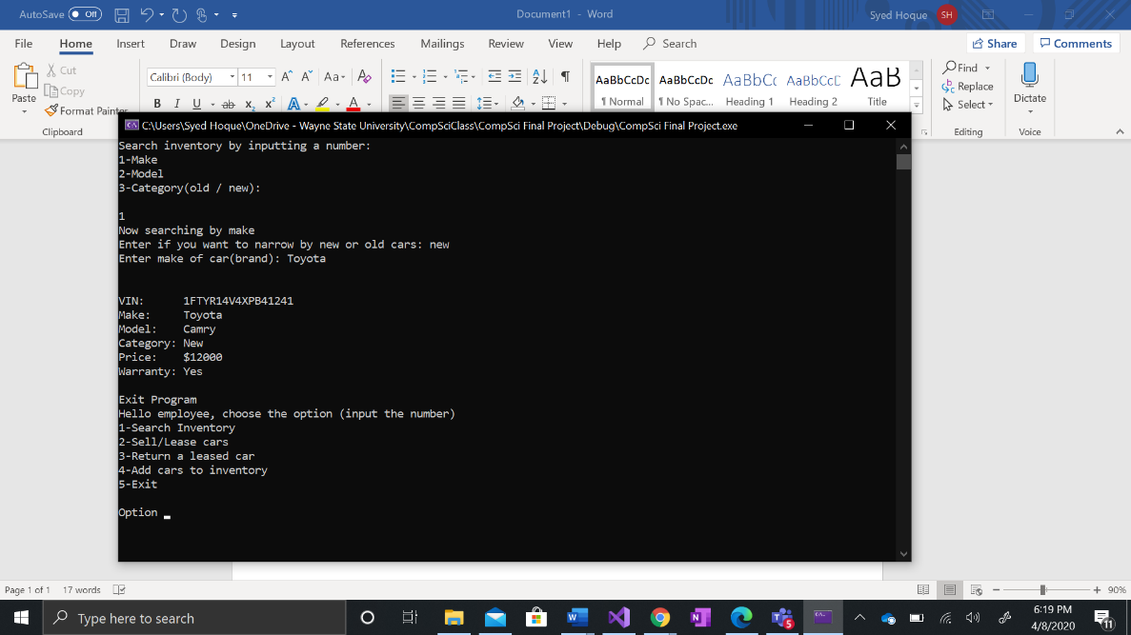 Search by make selected, typed in Toyota and Toyota was brought up

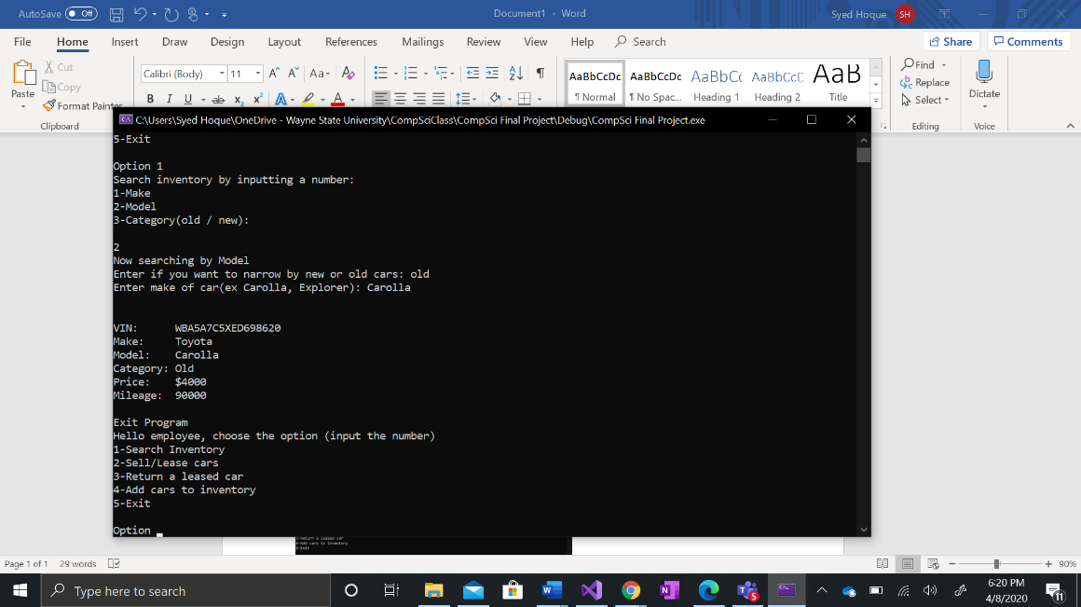Search by model selected, typed in Carolla and the Toyota Carolla was brought up

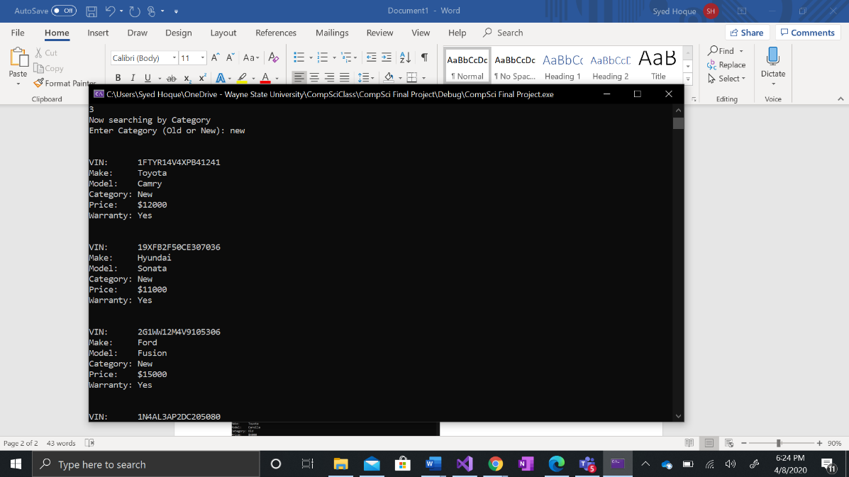 Searched by category and typed in new, all the new cars were displayed

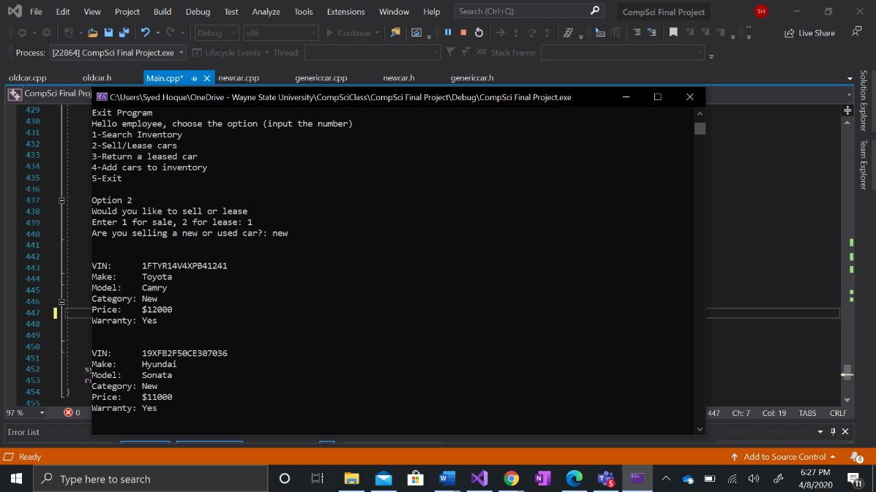Option 2 was selected to sell/lease a car. 1 was selected so a new car is being sold

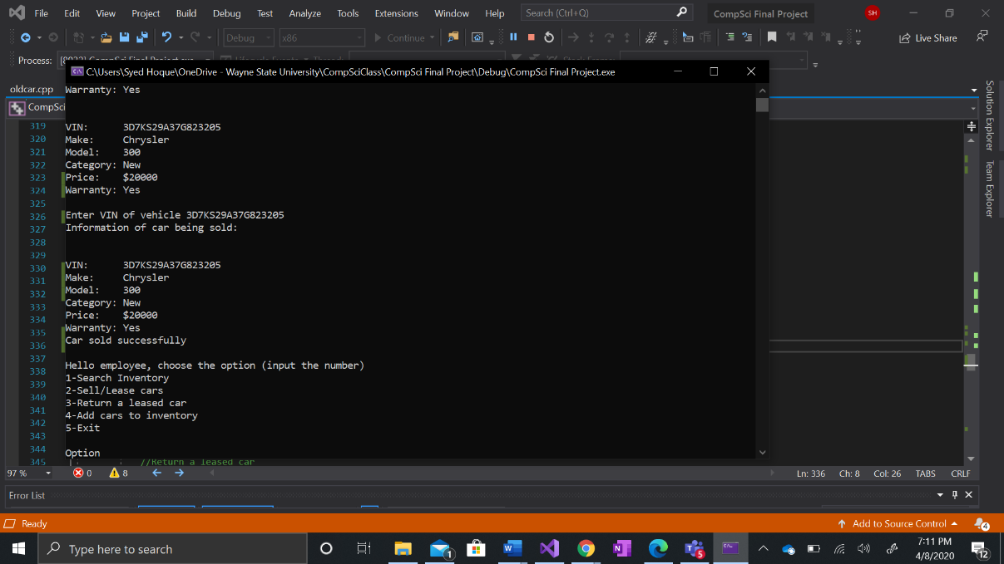The VIN of the car was entered showing its information and a sold confirmation was given

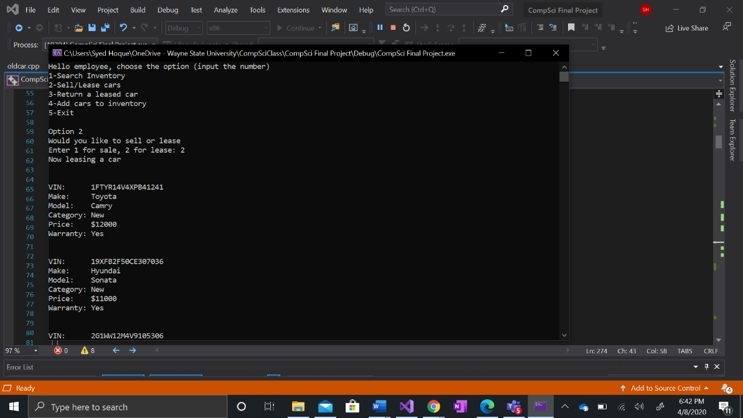For option 2, the lease option was selected a list of cars come up.

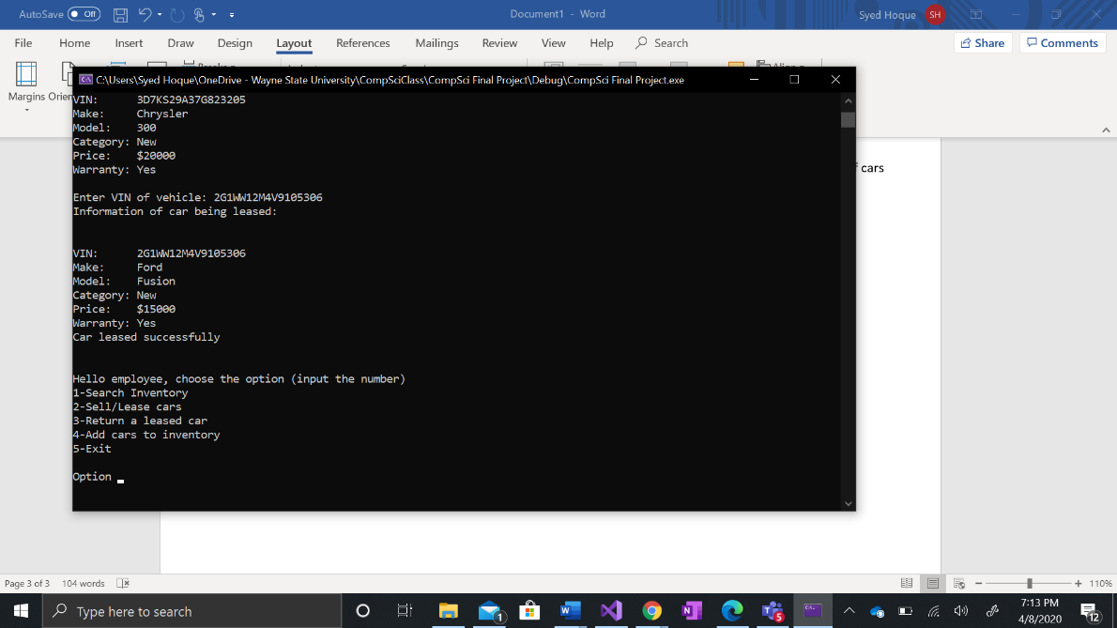

A VIN number was entered which shows the information of the car being leased and then the confirmation is given

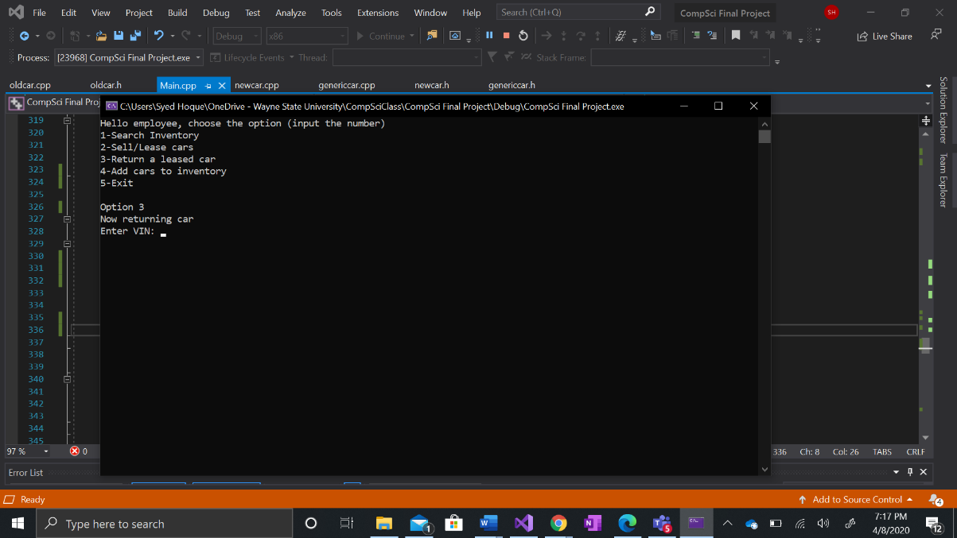Option 3 was selected which is the returning a car section and it asks the user for information regarding the car

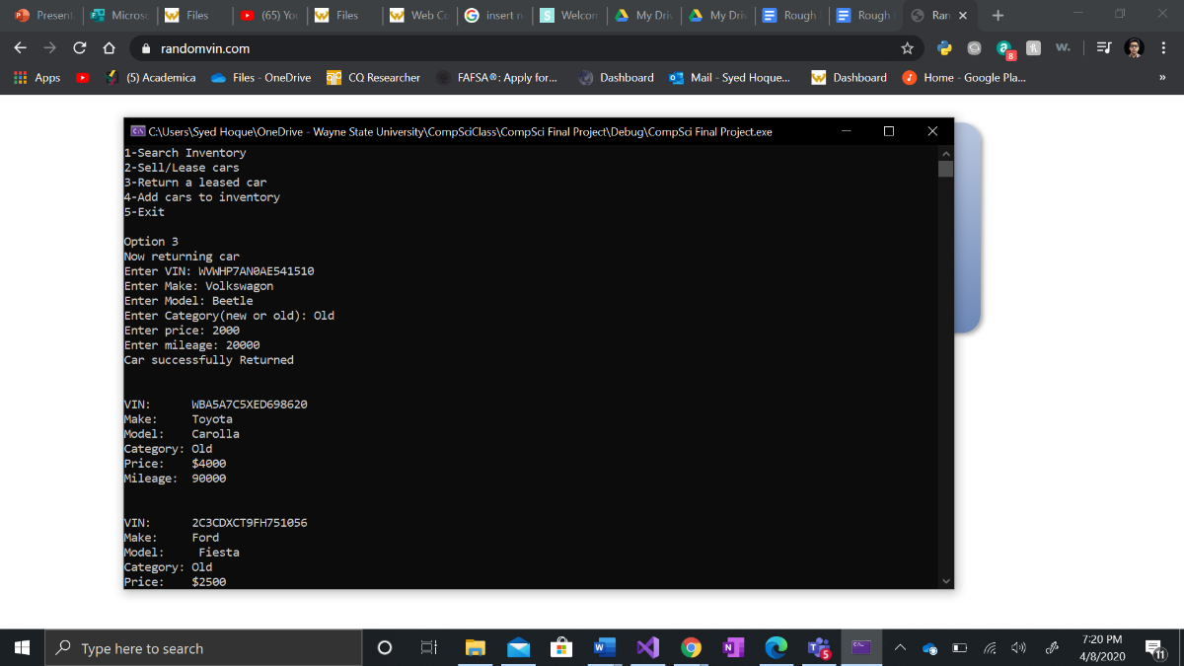After the information is added, the car return is confirmed

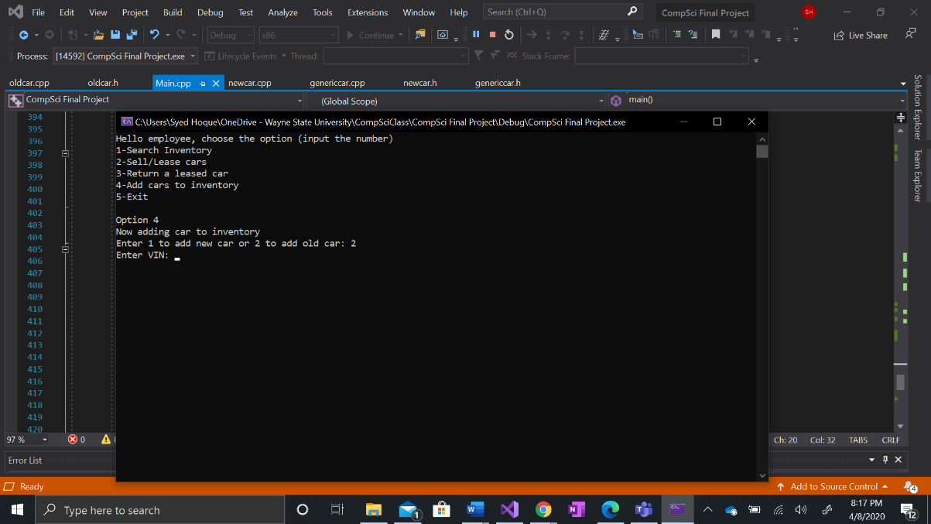Option was selected which lets the user add a car to both the new and old inventory

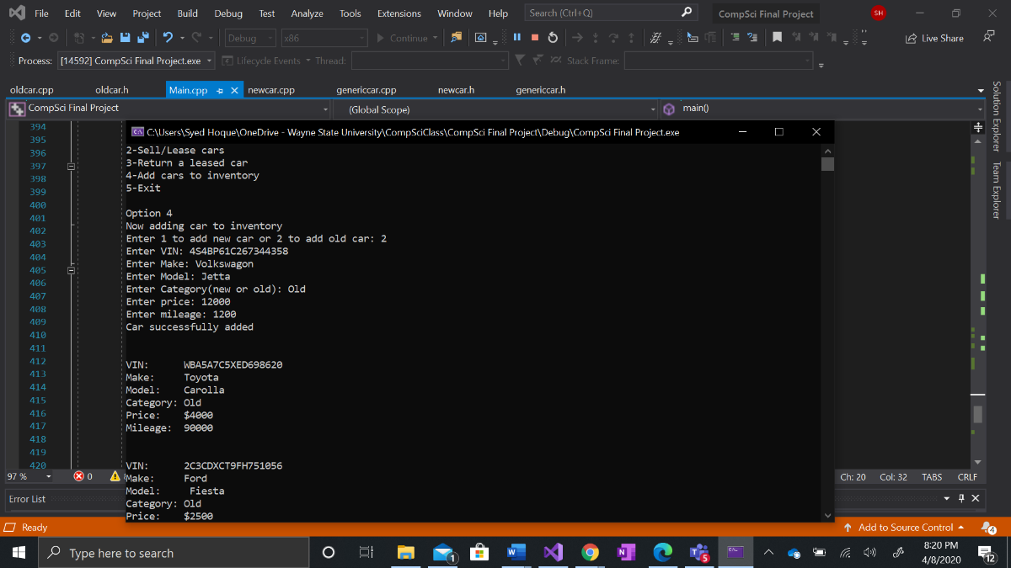 The user inputs the corresponding information and it is added to the list of used cars.

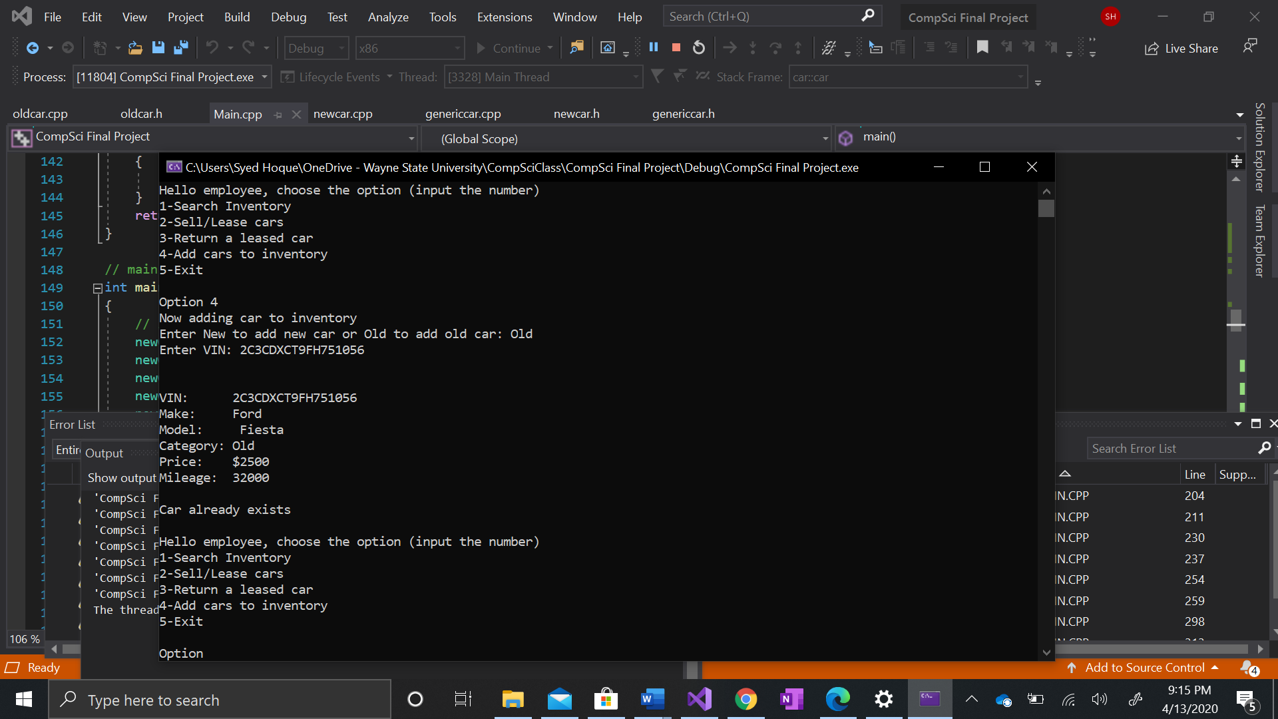If the user enters a car that is already in inventory, the program will them know

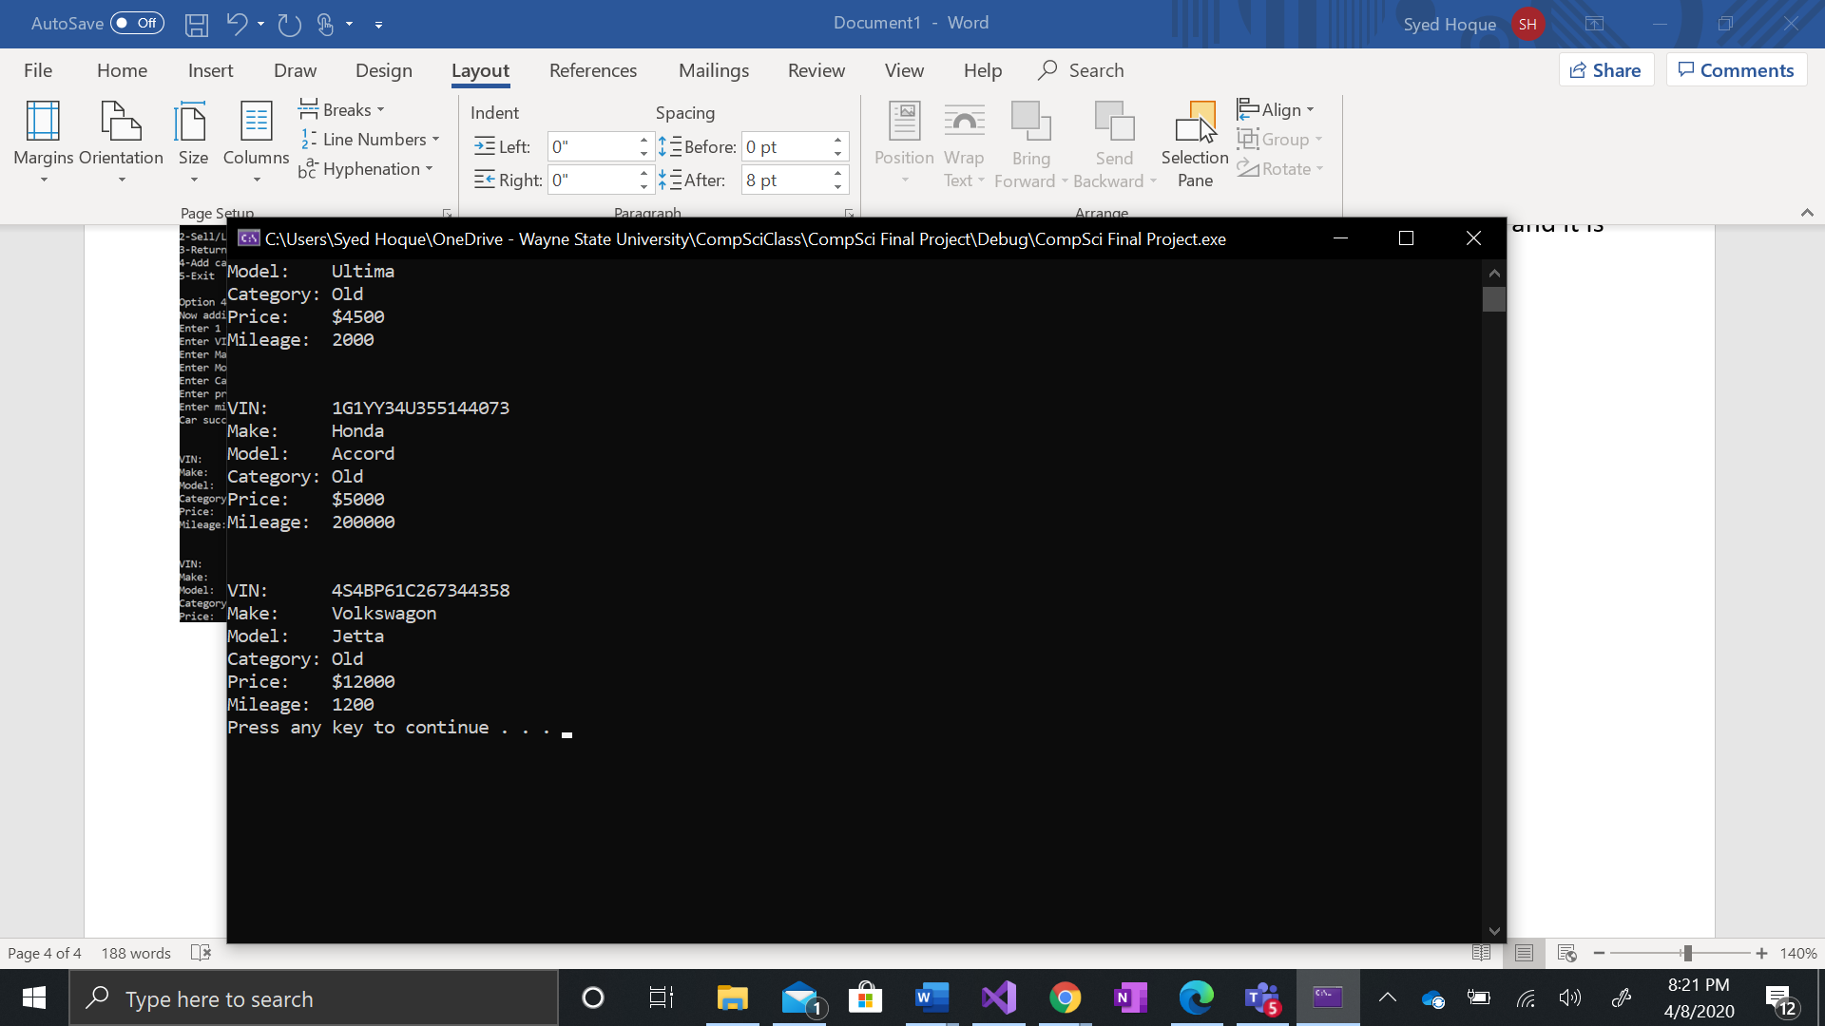 Here it is with the list of other used cars

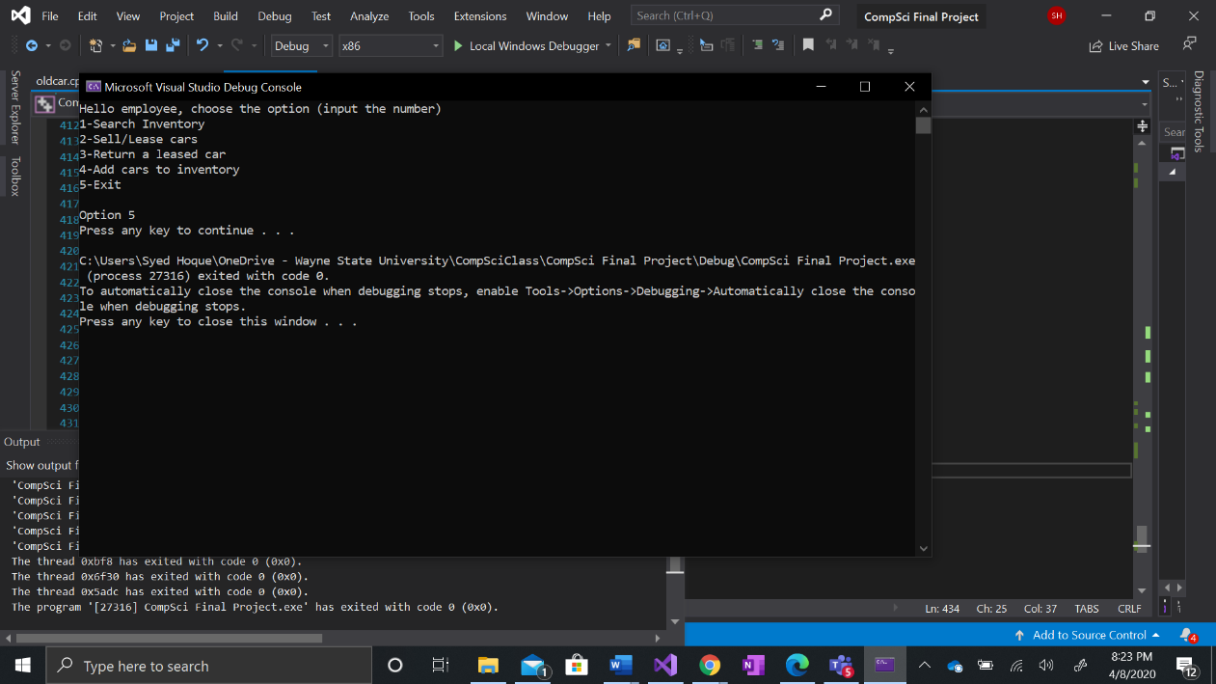Option 5 exits the program.

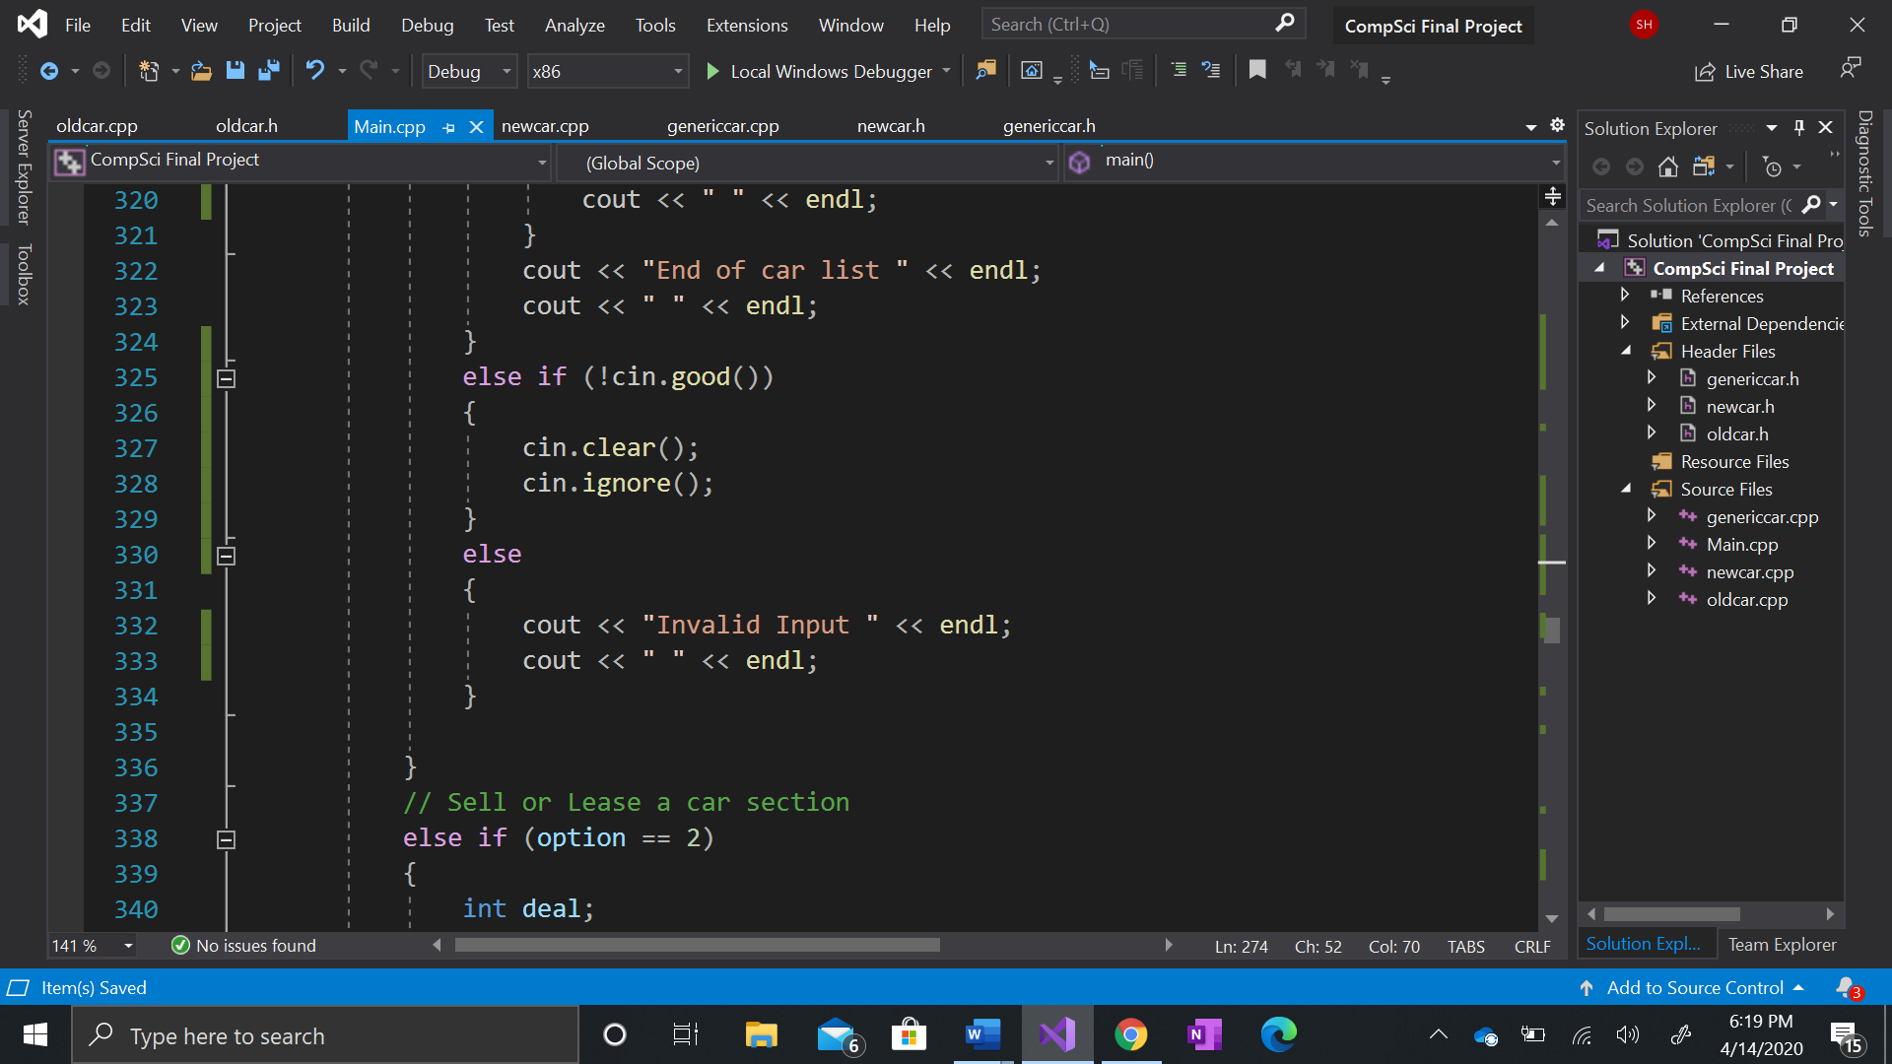 The use of the (!cin.good()) is there to check and make sure the invalid inputs do not break the program and also an else statement for things that the normal cin can handle

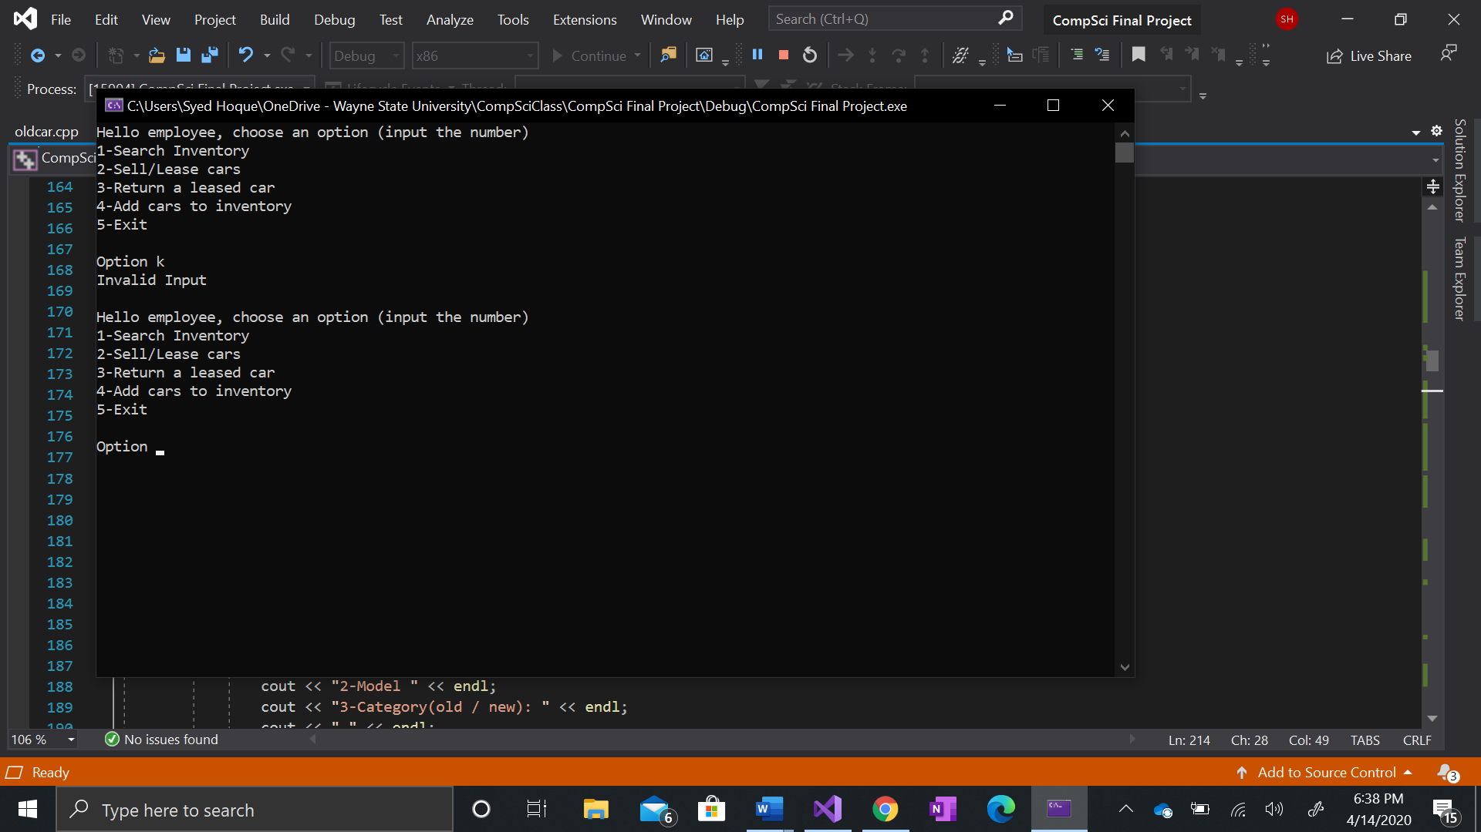Using the main menu as an example, the user must integer an integer but a character was inputted but the (!cin.good()) caught the error and prevented it from crashing the program. This is throughout the program

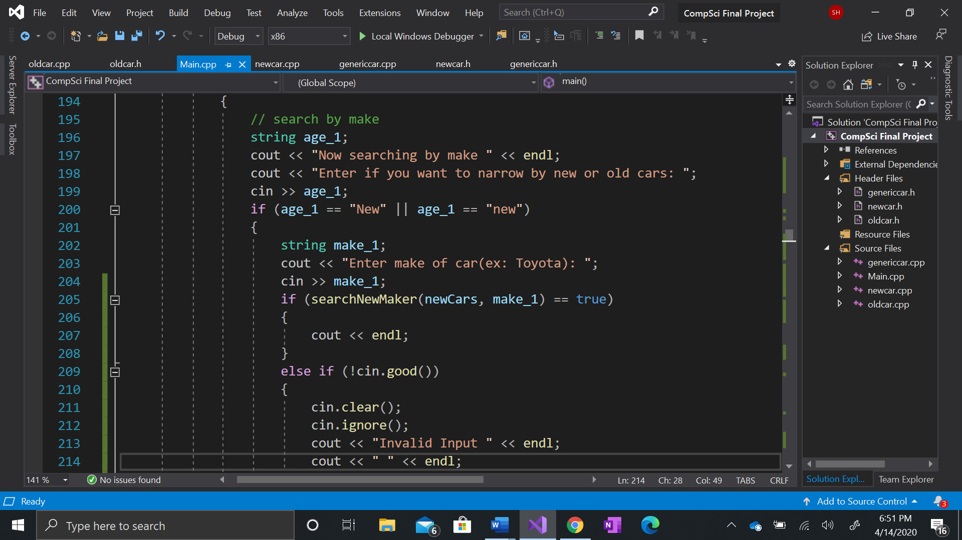The program also allows words to be spelled with either a capital letter or lower case.